1.6 Concept Selection
House of Quality
The first step that we took during our selection process was to create weights for each of
our customers' needs so we could determine the importance weight factors. We did this using the binary pairwise comparison chart in Figure 1. The customer requirements are listed in the rows, and we went cell by cell comparing each row to the column that corresponds to that customer
requirement. If the row requirement was more important than the column requirement the cell
was given a 1 and it was less important compared to the column the cell was given a 0. The total
across each row was calculated and this value corresponds to the weight for that customer
requirement. Keeping the temperature of the module under the required operating temperature had the highest importance weight factor.
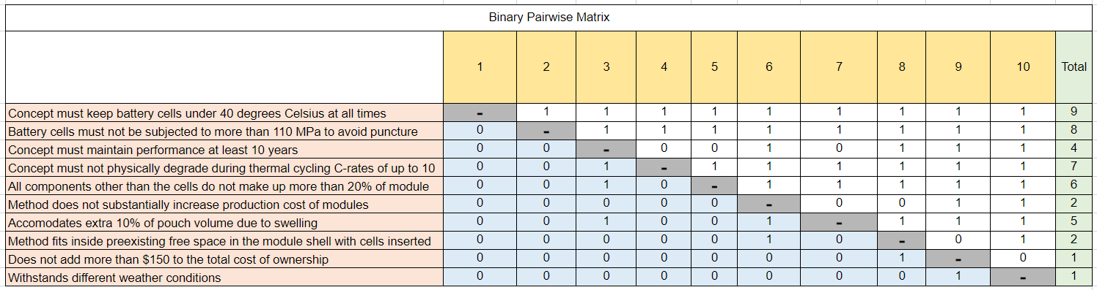Figure 1: Binary Pairwise Comparison of Customer Needs

The importance weight factors calculated using the binary pairwise comparison were then entered into the House of Quality presented in Figure 2. Our customer requirements are listed in
the rows, and the engineering characteristics are listed in the columns of the table. The
engineering characteristics were determined from our functions and targets. We went row by row and determined if the engineering characteristic would contribute to fulfilling the customer
requirement. A value of 9 was given if the engineering characteristic significantly contributed, a
3 was given if it moderately contributed, a 1 was given if it slightly contributed, and no value
was given if it did not contribute at all. A score was then calculated for each engineering
characteristic. From the relative weights of the engineering characteristics, we determined that
the most important characteristics were the ones that had a relative weight greater than 10%.
The outcome of the House of Quality chart was that the engineering characteristics that we would use as decision making criteria were temperature, avoiding puncture, thermal cycling, accommodates swelling and minimizing total cost of ownership. These decision-making criteria were then used to evaluate the Pugh chart and analytical hierarchy process.
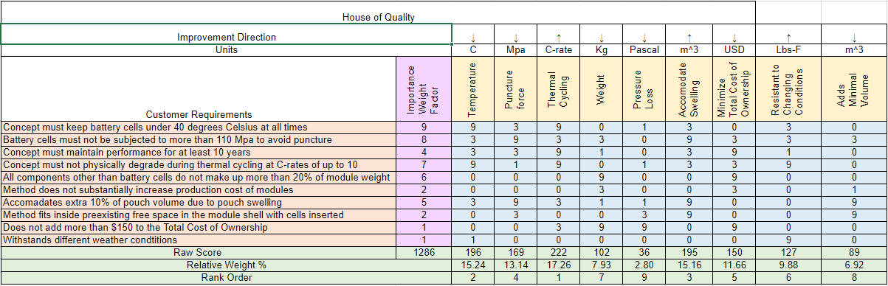Figure 2: House of Quality

Pugh Chart
Using the engineering characteristics that were determined to be most important to our design we utilized a Pugh chart to compare our top concepts to a datum. The datum that we compared our concepts to was the Nissan Leaf module. The Nissan Leaf uses an air-cooled battery pack with cooling tabs between the modules to transfer heat out of the modules to the ambient air. We compared the medium and high-fidelity concepts shown in Table 1 using the Pugh Chart shown in Figure 3. The criteria that is better than the datum was given a +, the criteria worse than the datum was given a -, and the criteria that performs the same as the datum was given an S. Each concept was compared, and the number of pluses and minuses were totaled. From here we moved forward with the concepts that had the most pluses and least minuses.

Table 1: Medium and High-Fidelity Concepts
Abbreviation | Concept Description
Phase Change | Using salt hydrate phase change materials (PCM) to absorb heat
Plates between Modules | Cooling plates in between modules with coolant flowing between them
Cabinet Cooling | Cabinet based holding for pouch cells with gap in between each cell to allow for coolant flow
Channel Snake between Cells | Coolant channel that snakes between the cells and outputs to a heat sink
Angle Slits | Angle slits on the battery pack to increase the amount of airflow into the modules
Cooling Pipes Inner Shell | Route liquid cooling pipes around the inner shell of module wall with aluminum plates between cells to transfer heat to pipes.
Thermal Paste | Create thermal paste packs that increase contact area between cells and module walls
Conductive Tape | Layer highly thermally conductive tape between cells to transfer heat to the side of the module to which the coolant channels are connected

From the initial Pugh chart in Figure 3 it was determined that the concepts that would move on to the next Pugh chart was the Cabinet Cooling, Cooling Pipes on Inner Shell, Thermal Paste, and Conductive Tape. The channel snake between cells had a high number of plusses and minuses, so it was chosen as the datum for the next Pugh chart. The Phase change and angle slits concepts were eliminated due to having the least number of pluses. These two concepts had a lot of satisfactory marks meaning they would perform similar to the Nissan Leaf cooling system.

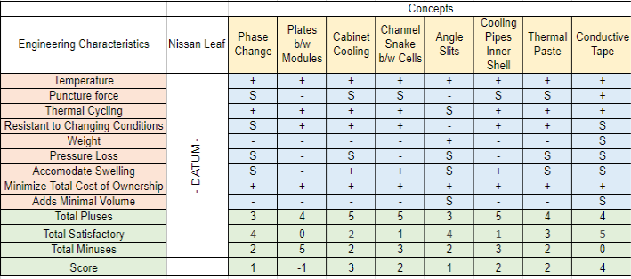
Figure 3: Initial Pugh Chart
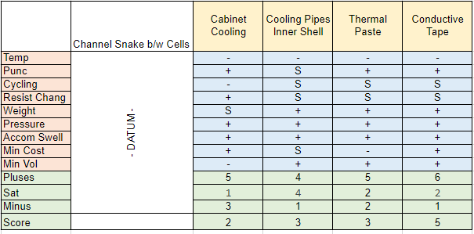
Figure 4: Top Concepts Pugh Chart
We set our medium fidelity concept Channel Snake between the cells as our datum for the final Pugh chart. Figure 4 shows the second Pugh chart that was used to compare the final four concepts to the new datum. After comparing the concepts to the new datum, it was determined that conductive tape (concept #54) was the best design followed by thermal paste (concept #99) and cooling pipes inner shell (concept #22). In the final Pugh chart, the conductive tape has the most pros, the only con is that it does not cool as much as the datum. The cooling pipe method satisfies most of the needs with very few cons, but the thermal paste is more resistant to puncture, which is why they tie for second best concept. After reviewing the final pugh chart, cabinet cooling will be ignored for its added volume and not being resistant to thermal cycling. The Cabinet Cooling option had the highest number of minuses in key areas such as temperature, adds minimal volume, and withstanding thermal cycling. The three remaining concepts that were moved forward to the analytical hierarchy process were the thermal paste, cooling pipes inside inner shell, and thermally conductive tape concepts.

Analytical Hierarchy
An analytical hierarchy process was used to first determine the importance of each engineering characteristic to the project. Each characteristic was weighed against each other to see which one was more important. If the characteristic was determined to be more important to the project it would receive a higher score, such as a 5 or 7. Otherwise it would receive a lower score, such as 0.2 or 0.3. Figure 5 shows the overall scores of each characteristic, and its normalized chart to show which one came out most important.
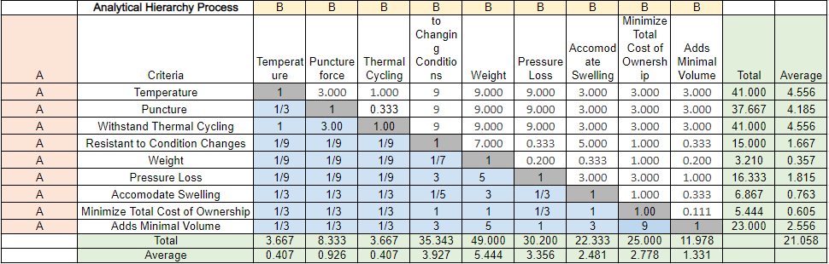
Figure 5: Comparison Matrix of Engineering Characteristics
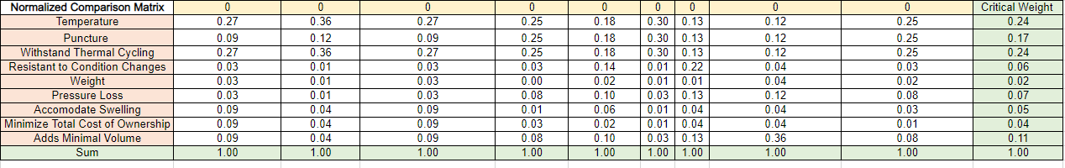Figure 6: Normalized Engineering Characteristic Comparison Matrix
After going through the process, it was found that the temperature and withstand thermal cycling characteristics were the most important to the success of the project. Puncture and adding minimal volume to the module were also found to be important to the project, though not as much. After that, the three best concepts that were determined through the pugh chart were weighed against each other to determine which concept would best meet the critical characteristics. If a concept was determined to more successfully meet the characteristic, then it would receive a higher score, similar to the scoring done for the comparison matrix. Those values were then put into the final selection table so that each score could be compared. It was found that the cooling pipes concept scored the highest in the temperature and withstand thermal cycling characteristics while the conductive tape concept scored the highest in the other two categories. Figure 7 shows the final selection table that has the scores for each concept.
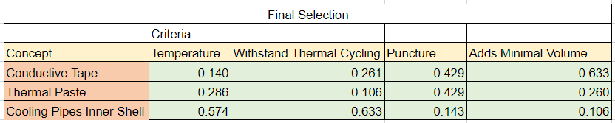Figure 7: Final Selection Table
This table was then used to find our alternative value table, seen in Figure 8, that would ultimately show which concept is the best. The alternate value table shows that the cooling pipes with inner shell concept was the highest score and is the concept that the team will move forward with.
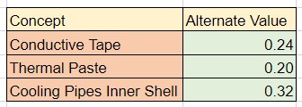
Figure 8: Alternate Value Table
Selection
After analyzing the Analytical Hierarchy Process the cooling pipes on inside of module shell was determined as the winner and the concept that our team will move forward with. This concept (Concept #22) involves routing liquid cooling pipes around the inner shell of the module walls with aluminum plates between the cells to transfer heat to the coolant pipes. This concept takes advantage of liquid cooling to provide more heat transfer within the cell. The specific heat of fluids such as water are much higher than air. The fluid that will be used for our final design has not been determined yet but one option that we have investigated is a glycol water mixture. Also, routing the cooling pipes around the module gives the pipes more space which will allow them to have a larger diameter which will reduce the pressure drop within the pipes. The use of the aluminum plates will allow the heat from each cell to transfer in multiple directions to reach a pipe, keeping the temperature gradient across the cell constant. If higher heat transfer is needed the fluid flow rate can be increased to improve heat transfer within the module. This design will take advantage of wasted space around the module walls where the pouch cells do not contact each other. Figure 9 shows a sketch of the design. There will be a supply line that connects the cool coolant to the module. From the connection the fluid will split off into each of the cooling pipes. The pipes will wrap around the outside of the module collecting heat from the aluminum plates that are between the cells. The fluid will join back at the outlet and then go into a return line. The aluminum plates between the cells will be joined with the cooling pipes so that the heat can transfer from the plates to the fluid.

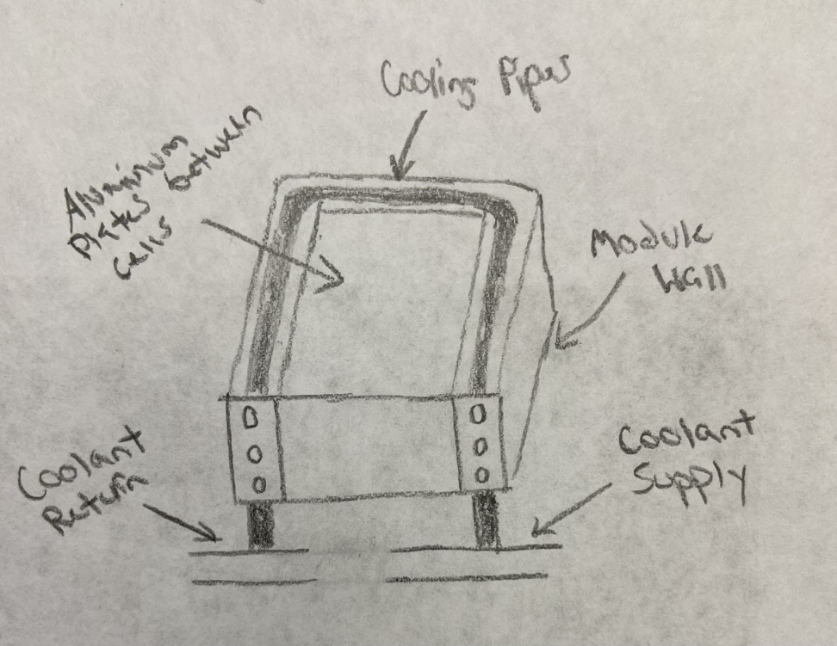
Figure 9: Final Selection Sketch
Appendix D: Concept List
- Use peltier device within module to help generate electricity without raising temperature
- Change layout of cooling channels to reduce losses
- Make use of copper's high conductivity to take away more heat
- Make use aluminums high conductivity to take away more heat
- Reduce the distance between plates to increase the heat rate
- Add fans to induce airflow into the module to increase the heat taken out
- Add more cooling plates to the module
- Add fins to the cooling plates with induced airflow to increase heat taken out
- Increase the amount of cooling channels to increase heat taken out
- Increase the area of the cooling plate to increase heat taken out
- Decrease the thickness of the cooling plates to increase heat taken out
- Cooling plates in between modules with coolant flowing between them
- Add holes/slits in battery pack to allow for increased airflow
- Increase the convection heat transfer coefficient (h)
- Using salt hydrate phase change materials (PCM) to absorb heat
- Using paraffin PCM to absorb heat
- Heat pipe design with an air-cooled end
- Heat pipe design coupled with coolant flow
- Submerge the cells in coolant Batter
- Submerge module in ice pack
- Put batteries inside the vehicle and place them in a refrigerator
- Route liquid cooling pipes around the inner shell of module wall.
- Add carbon fiber plates between cells to increase conduction from cells.
- Add cooling plates between each cell and run coolant through the plates.
- Pump antifreeze over the modules when they overheat
- Coolant is run through a fan cooled radiator
- Use lightweight material so less energy is required to operate the vehicle
- Use evaporative cooling method
- Use aluminum foil sheets to increase the contact area of cooling
- Use heat sink to force heat out
- Spray coolant onto cells onto cells and cooling plates
- Add AC system to battery pack
- Tilt batteries and spray coolant, allow for coolant to run down modules and fall to bottom of pack, pump waste out
- Spray coolant on batteries intermittently and let coolant pool on bottom, add cooling element to the pooled coolant and slowly pump it out
- Placing pack on cooling/heating pad
- Submerge module in coolant, constantly pumping in cool coolant while pumping out hot coolant
- Submerge module in coolant while constantly cooling the pool
- Serpentine pipes between modules
- Insert dry ice into modules before each use
- Have a bunch of tiny fans blowing
- Single cooling pipe that goes around module with aluminum plates to transfer heat to the fluid
- Cold plates with dimples inside induce turbulence on flow to increase conduction
- Thermally conductive tape between cells used in electronics to transfer heat
- Create thermal paste packs that increase contact area between cells and module walls
- Coolant channel that snakes between the cells and outputs to a heat sink
- Cooling plate with entire plate filled with coolant instead of using pipes
- Energy is pulled from other sources when the batteries overheat
- Drilling holes in the module walls to increase natural convection
- Plate heat exchanger that has the cells fitted between it and fluid flows through it
- Diamond plated heat exchanger
- Gold plated heat exchanger
- Cabinet based holding for pouch cells with gap in between each cell to allow for air flow
- Cabinet based holding for pouch cells with gap in between each cell to allow for coolant flow
- Layer highly thermally conductive tape between cells to transfer heat to the side of the module to which the coolant channels are connected
- Angle slits on the battery pack to increase the amount of airflow into the modules
- Using AC pump to provide cold air to the modules, similar to building hvac
- Use insulation to conserve cool air, then extract hot air through holes in the top
- Air compressor on vehicle compresses air and as air is released into the module and the drop in pressure reduces temperature in air going into module
- Add scoops to battery pack to increase the amount of airflow
- Use silver plates between the cells to transfer heat at a higher thermal conductivity
- Use a hydrogel of a polyacrylamide framework infused with water and specific ions. When hydrogel is heated, electricity is produced creating less strain on the batteries.
- Decrease the surface roughness of cooling channels to minimize losses
- Cells are immersed in a dielectric fluid and the fluid absorbs the heat as the battery cells heat up
- Increase the diameter of the cooling channels to reduce losses
- Switching the side of the tabs of the cell so they are on opposite ends of the battery module.
- Use liquid nitrogen heat exchanger to cool battery
- Use liquid helium for better efficiency and to cool the battery
- Bring outside airflow into a radiator inside the battery pack
- Intermittently drop dry ice into pack during operation
- Use cooling plates with modules submerged in a cold pool of liquid
- Route heat from cooling plates to battery pack and have outside airflow cool battery
- Add fins to battery pack
- Submerge battery pack in coolant
- Spray coolant on battery pack
- Use regular cooling plates and spray extra cold coolant into the network when heat is too extreme
- Use a fan to blow evaporated liquid nitrogen into the module
- Have a rotating cold plate, as one plate gets hot rotate in one that has been precooled
- Focus cooling on one part of the cell so that it overall doesn’t overheat
- Connect cooling channels to fins on the battery pack and route them into the cooling plates in the module
- Use shell and tube heat exchanger to help direct air and coolant flow to effectively cool cells
- Submerge battery pack in cold pool and insulate the pool, have hot liquid circulated out and cooled using outside airflow and bring it back into the pool
- Use barbed pipes to increase the surface area of the pipes and increase the amount of heat taken out
- Periodically pour coolant onto cells
- Put cells on rotating piece that dumps them into coolant as the piece rotates
- Put cells on rotating piece that dumps them into coolant as the piece rotates and spray coolant onto the cells at the top of the rotation
- Use baffles to prevent the cooling channels from vibrating and losing energy
- Spread cells out with one cooling plate per cell
- Decrease the length of cooling channels but increase the number of passes
- Use smoother cooling channels to decrease losses
- Have sliding piece in module that goes to each cell spraying coolant
- Pour coolant onto cells, have it pool at the bottom, as it gets hot pump it out and recool It
- Use smoother channels with higher damping on the battery to decrease losses
- Have coolant injectors on a rail in the module that intermittently spray coolant
- Use a sprinkler type system that can spray the whole module with coolant
- Use a system similar to a building’s fire suppression system that can spray coolant in the module
- Use system that can constantly pull out hot cells and dunk them in a coolant reservoir
- Tilt cells and have coolant run over them and out of a slit on the other side
- Have fan pointed on cells and oscillate the cells to have even distribution of airflow
- Use thermal paste to improve the contact area of cooling
- Use freeze gun to cool modules

